Plan server systems
By Haydn Roberts

The server for this project will host a database alongside a processing backend codebase.
The codebase will be made to host the computational functions that would use up too much battery on the IoT device. This code will follow security principles like OWASP to ensure that all data connected to this project is secure.

For the database, carers need to be linked to patients and patients need to be connected to their devices. There are two solutions to this scenario, one where each patient has a single device, and a second solution where a patient can have access to multiple devices.
In third normal form, these solutions can be presented as this:
Single device solution:
carer_table:
carerId – primary key
carerUserName
carerPassword
patient_table:
patientId - primary key
patientName
deviceId
deviceIdentifier (e.g. the phone number that the device contacts the system with)

join_table:
joinId - primary key
carerId – foreign key
patientId - foreign key

Multiple device solution:
carer_table:
carerId – primary key
carerUserName
carerPassword
patient_table:
patientId - primary key
patientName
device_table:
deviceId – primary key
deviceIdentifier (e.g. the phone number that the device contacts the system with)
patientId – foreign key
join_table:
joinId - primary key
carerId – foreign key
patientId - foreign key

Overall, the multiple device solution is preferable as it would make the process of changing the patients device (if it were to break or otherwise need changing) much simpler and this is a feature that will be required either way. This solution also makes the database much more readable which will make it easier to work with.
Here is the entity relationship diagram for this database:
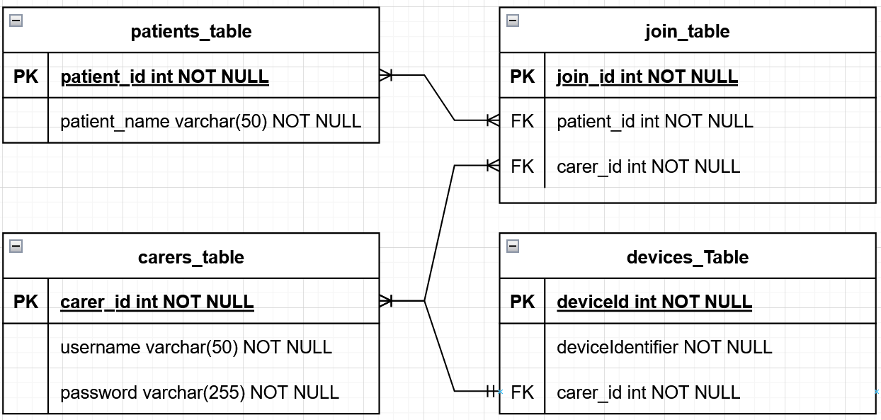
Many patients can have many carers and many carers can have many patients through the join table. A device may have one carer and one carer may have many devices.
OWSAP:
The Owsap top ten is a standard for web application security, it represents a broad consensus about the most critical security risks to web applications. As a group, we should utilise this information to produce more secure code and minimise the potential risks associated with online security.

OWASP top 10 2017:
1: injection
2: broken authentication
3: sensitive data exposure
4: xml external entities
5: broken access control
6: security misconfiguration
7: cross site scripting
8: insecure deserialization
9: using components with known vulnerabilities
10: insufficient logging and monitoring

OWASP top 10 2021:
1: broken access control
2: cryptographic failures
3: injection
4: insecure design
5: security misconfiguration
6: vulnerable and outdated components
7: identification and authentication failures
8: software and data integrity failures
9: security logging and monitoring failures
10: server side request forgery

OWASP top 10 2025:
1: Broken Access Control
2: Security Misconfiguration
3: Software Supply Chain Failures
4: Cryptographic Failures
5: Injection
6: Insecure Design
7: Authentication Failures
8: Software or Data Integrity Failures
9: Logging & Alerting Failures
10: Mishandling of Exceptional Conditions

